Project 2-1: Area and Perimeter Calculator

User interface
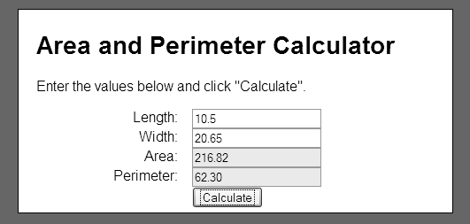

Operation
- This application allows the user to enter values for the length and width of a rectangle.
- This application displays the area and perimeter of the rectangle after the user clicks on the Calculate button.

Specifications
- The formulas for calculating area and perimeter are:
area = width * length
perimeter = 2 * width + 2 * length
- This application should make sure that the user enters a positive number for the length and width.
- This application should accept decimal entries like 10.5 and 20.65 for the length and width.
- This application should round the area and perimeter to 2 decimal places.

